Who we are

Xxxx Ruritan Club has served the Xxxx Community since ####. Ruritan members work to enhance the quality of life through community service and to make our community a better place to live and work.



Ruritan is Families, Fun, Friends

Xxxx Ruritan Club is proud to be an organization of positive people doing positive things in our community. We take pride in the things we bring to (Community Name).

Xxxx Ruritan Club meets monthly:
DATE:
TIME
LOCATION:

Meal service, club business and an informational or entertaining program are part of each meeting.
What we do

Xxxx Ruritan Club works to improve the community through five service areas: Business & Professions; Citizenship and Patriotism; Environment; Public Service; and Social Development.

Ruritan National Foundation provides financial assistance to help students further their education after graduation from high school. In addition, hundreds of Ruritan Clubs award annual scholarships and grants to deserving local students.

Ruri-Teen Clubs are formed when groups of students, sponsored by an existing Ruritan Club, choose to form a service club in their local school.

The Ruritan Student Program introduces youth to the Ruritan spirit of Fellowship, Goodwill and Community Service by sponsoring students as members of local Ruritan Clubs.
How we do it
RURITAN MISSION
Ruritan is a national organization dedicated to improving communities and building a better America through fellowship, goodwill and community service

Xxxx Ruritan Club committees can propose and implement projects and programs to fulfill community needs and may include:
- Does your club sponsor Little League or other athletic programs or provide community athletic fields?
- Award scholarships?
- Sponsor scout units?
- Support 4-H, FFA and FHA?
- Sponsor students to leadership programs at 4-H Citizenship Washington Focus and Freedoms Foundation’s Youth Leadership Conference?
- Sponsor roadside clean-up and anti-litter drives?
- Promote industrial development in the community?
- Support life-saving squads and fire departments; sponsor blood donation programs, Bloodmobiles?
- Assist the elderly and infirm?
- Construct community parks; providing community centers and meeting places?
- Support drug abuse education and information programs?
- Form Ruri-Teen Clubs in local schools to instill a spirit of community service in our youth at an early age?
- Donate plush Rudy Bears to hospitals, school counselors and law enforcement agencies to cheer and comfort children in time of crisis?
Benefits of Membership

Xxxx Ruritans believe the most important benefit of membership is the opportunity to work in fellowship with people, who like them, have a desire to make their communities better places in which to live.

In addition, Ruritan members receive a quarterly magazine of Ruritan news and community service tips. Leadership training and personal development programs help Ruritan members get the most of out of their efforts.

Ruritan members receive group discounts from Choice Hotels, American Express, Alamo Car Rentals and other nationally known businesses that recognize the importance of volunteer service contributions.

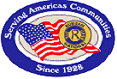

Ruritan National
P.O. Box 487
Dublin, Virginia 24084
Phone (877) 787-8727
Email – office@ruritan.org
Website – www.Ruritan.org
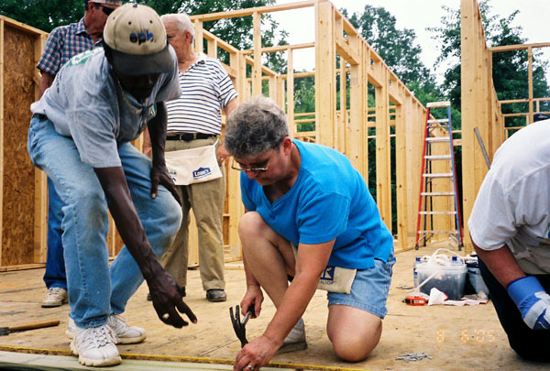

Ruritans meeting community needs

How to get involved

Just complete a membership application and submit a one-time $$ initiation fee.
Monthly dues are $$ and include meals. We don’t see strangers, just friends we’ve never met.

Come join us for our monthly meeting:

DATE: Day of week
TIME:
LOCATION: Meeting Place
Street Address
City, State

To request your membership application or to find out more about Ruritan, contact Name (XXX) XXX-XXXX or via email, emailaddress@.com

Reservations are not necessary, but come and learn what Xxxx Ruritan is all about.
Community people meeting
community needs
EXISTING CLUB
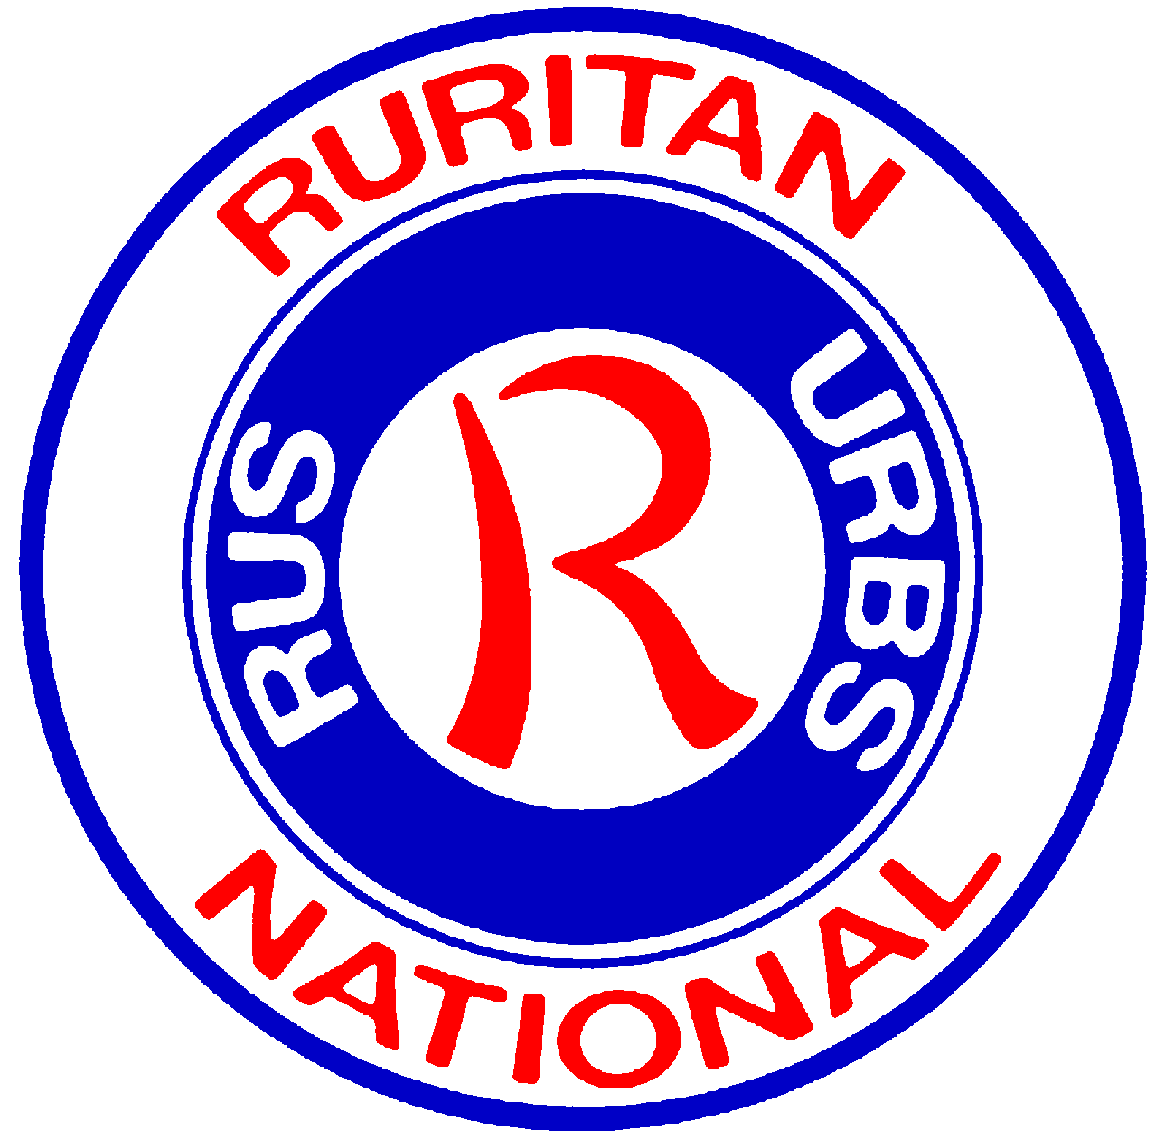

Celebrating XX years of service
Xxxx Ruritan Club

Xxxx, Xxxx

