Club Meeting – 7:00 p.m.
Tuesday, January 16, 2007

• Call to Order
Vice President Sue Belke
• Invocation
Pastor Roger Penske

• Welcome
President Chuck Taylor
• Song – “America”
Pat Boon
MEAL SERVICE
Downingtown VFW Post 6 Auxiliary

• Introductions
New Member Mary Kate

• Business – Officer’s Reports
⬥ Secretary Brandy Glass
⬥ Treasurer Bill Gates
⬥ Membership – Adam Upp
⬥ Social – Holly Dais
⬥ Spring Project – Sandy Lane

• Induction of New Members
⬥ Past President Tim Allen
• Program Von Trapp Family

• Pledge of Allegiance George Spaton

• Adjournment
FOSTER RURITAN CLUB
Brooks, Alabama
Chartered: May 22, 1957

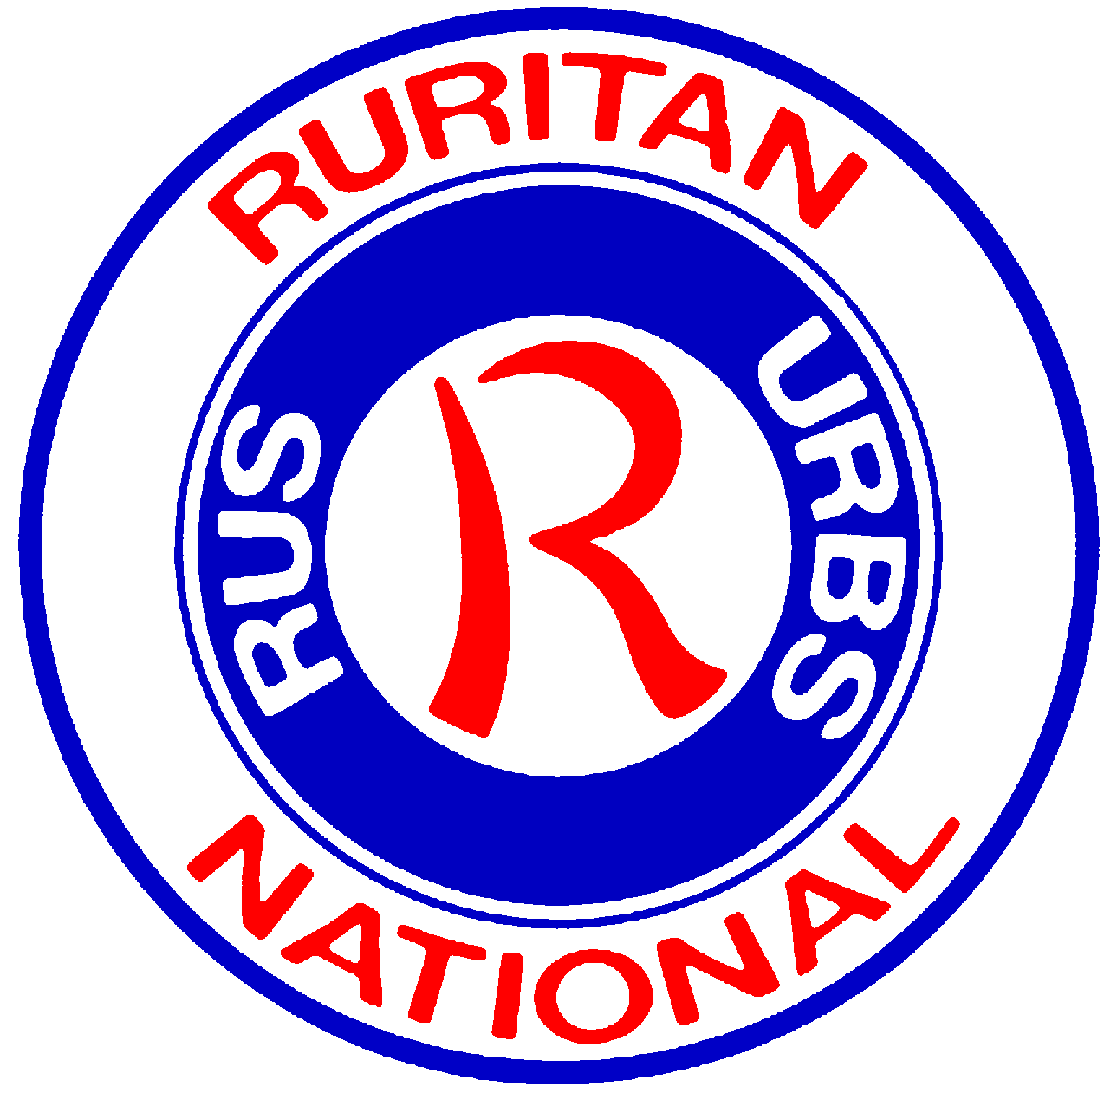

Celebrating 49 years of service

PROJECT CALENDAR – 2007
January Pancake Breakfast
Community Center Workday
February
Valentine’s Day @ Senior Center
Paint-Up, Fix-Up with Agency on Aging
March Clean-Up Day @ County-wide
Raffle for Salvation Army Donation
April Clean-Up Day @ Ruritan Park
Inter-Club Social @ Campbell Ruritan Park
May Opening Day @ Ruritan Park
Open Concession Stand @ Ruritan Park
Scholarship Presentation @ High School
June
Volunteer @ Campbell Pool Opening
Peanut Boil @ Campbell Days Parade
July
Take Kids Fishing @ Sweet Creek
August
Volunteers for End of Summer Festival
Operate Concession @ Ruritan Park
September
Park Cars @ High School Football
District Picnic @ Campbell Ruritan Park
October Spaghetti Supper
Shotgun Raffle
November
Thanksgiving Meal for Needy Families
December
Christmas Party for Needy Kids

