Who we are

Xxxx Ruritan Club is now forming with the purpose of creating a better understanding between people, and through community service, to make our community a better place to live and work. To meet this goal, the Xxxx Ruritan Club will survey the needs of the community and work to meet them.



Ruritan is Families, Fun, Friends

In addition to bringing an immediate identity to the Xxxx community, Ruritan offer our citizens the opportunity to work with others to enhance the quality of life and create a positive impact in Xxxx and Xxxx County.

Xxxx Ruritan Club meetings feature a fellowship meal function and meet once each month. Meal service, club business and an informational or entertaining program will be part of each meeting.
What we do

Xxxx Ruritan Club will work to improve the community through five service areas: Business & Professions; Citizenship and Patriotism; Environment; Public Service; and Social Development.

Ruritan National Foundation provides financial assistance to help students further their education after graduation from high school. In addition, hundreds of Ruritan Clubs award annual scholarships and grants to deserving local students.

Ruri-Teen Clubs are formed when a group of students, sponsored by an existing Ruritan Club, choose to form a service club in their local school.

The Ruritan Student Program introduces youth to the Ruritan spirit of Fellowship, Good Will and Community Service by sponsoring students as members of local Ruritan Clubs.
How we do it
RURITAN MISSION
Ruritan is a national organization dedicated to improving communities and building a better America through fellowship, goodwill and community service

Xxxx Ruritan Club committees can propose and implement projects and programs to fulfill community needs and may include:
- Sponsoring Little League and other athletic programs and providing local athletic fields.
- Awarding educational scholarships.
- Sponsoring scout units.
- Supporting 4-H, FFA and FHA.
- Sponsoring students to attend leadership programs at 4-H Citizenship Washington Focus and Freedoms Foundation’s Youth Leadership Conference.
- Sponsoring roadside clean-up and anti-litter drives.
- Promoting industrial development in the community.
- Supporting life-saving squads and fire departments; sponsoring blood donation programs, Bloodmobiles.
- Assisting the elderly and infirm.
- Constructing community parks; providing community centers and meeting places.
- Supporting drug abuse education and information programs.
- Form Ruri-Teen Clubs in local schools to instill a spirit of community service in our youth at an early age.
- Donating plush Rudy Bears to hospitals, school counselors and law enforcement agencies to cheer and comfort children in time of crisis.
Benefits of Membership

Xxxx Ruritans believe the most important benefit of membership is the opportunity to work in fellowship with people, who like them, have a desire to make their communities a better place in which to live, work and play.

In addition, Ruritan members receive a high quality membership card and a quarterly magazine of Ruritan news and community service tips. Leadership training and personal development programs help Ruritan members get the most of out of their efforts.

Ruritan members receive group discounts from Choice Hotels, American Express, Alamo Car Rentals and other nationally known businesses that recognize the importance of volunteer service contributions.

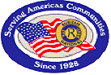

Ruritan National
P.O. Box 487
Dublin, Virginia 24084
Phone (877) 787-8727
Email – office@ruritan.org
Website – www.Ruritan.org
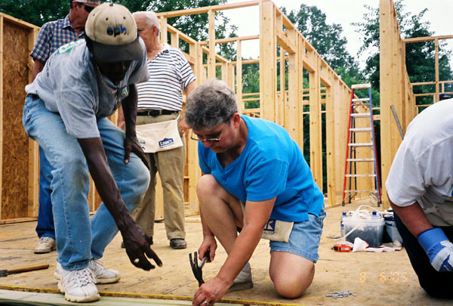

Ruritans meeting community needs

How to get involved

Just complete a membership application and submit a one-time $5 initiation fee.
When a group of 16 or more interested persons have paid the initiation fee, a new Ruritan Club will become official.

Come join us for an organizational meeting to be held:

DAY:
DATE:
TIME:
LOCATION:

To request your membership application or to find out more about Ruritan, contact Name (000) 000-0000 or via email, emailaddress@email.com.
Reservations are not necessary, but come prepared to join the area’s newest community service organization
Community people meeting community needs

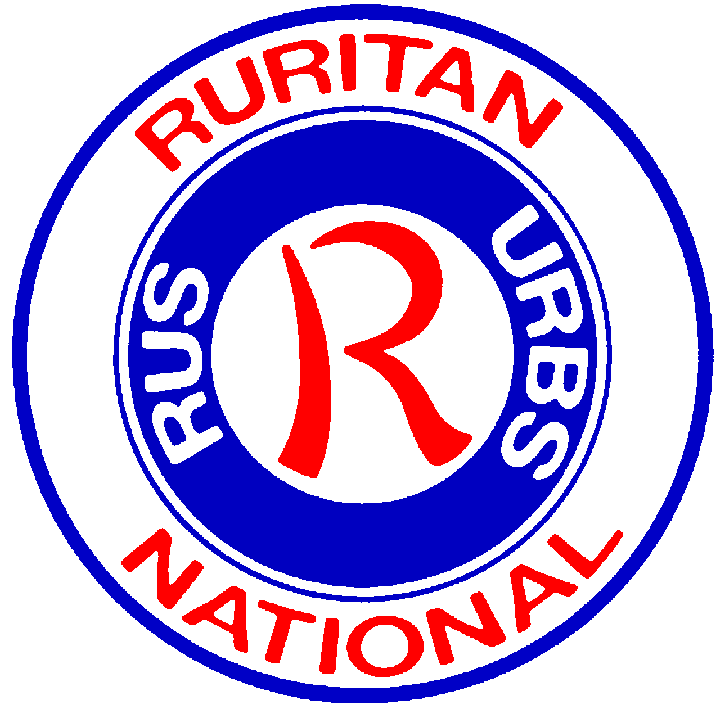

NEW CLUB
Ruritan Club

Xxxx, Xxxx

